Notes on accessing data
- SSH
- 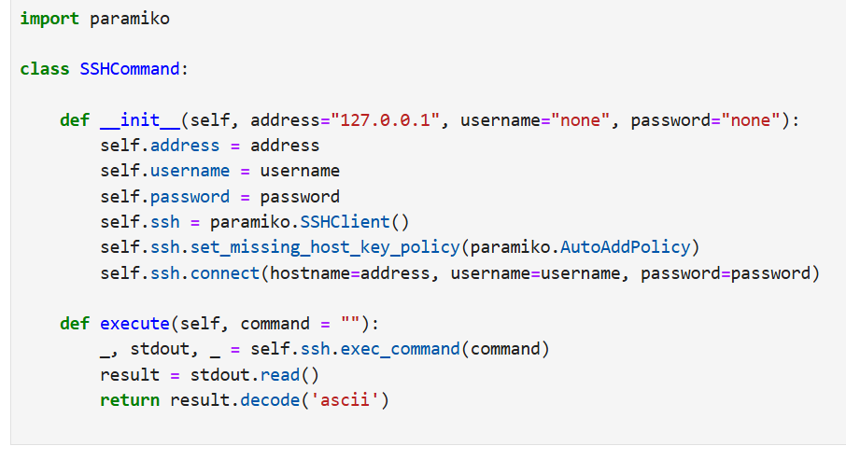
- SQL
- 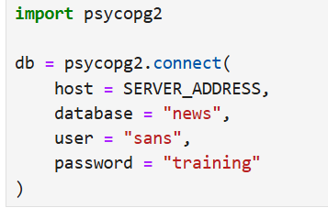
- 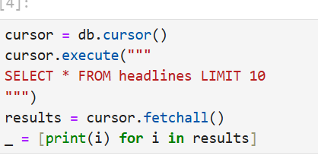
- Mongo
- 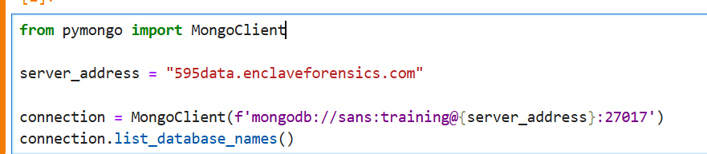
- This is a nice way to open a file and see what is inside:
- 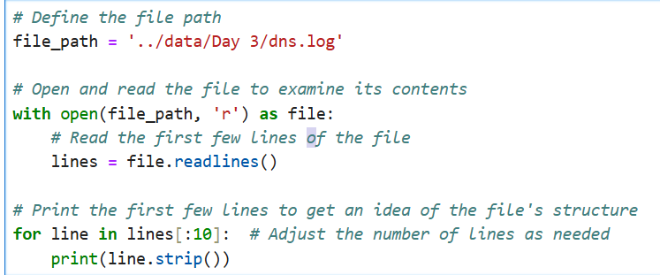
- read tab data in pandas:
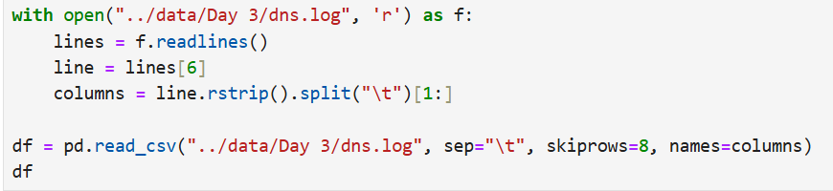
- example of reading through files:
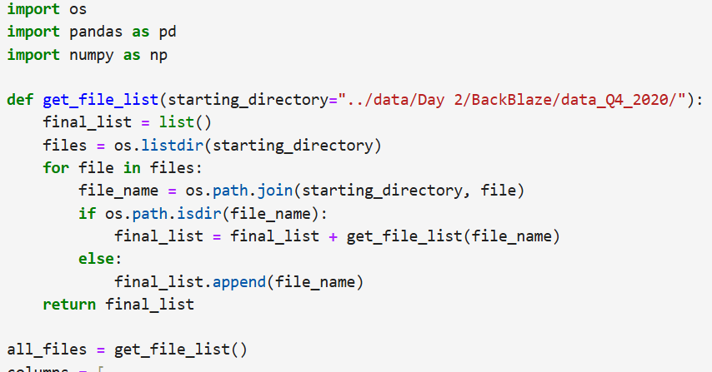

1.01 Python Review
- Setting up Jupyter Lab
- data types, lots of focus on tuples
- iterating with ‘for loops’
- F-Strings
- Enumeration while Iterating with an index
- built-in function, enumerate(),
- Exception Handling with try...except…
- Lists a_list = [1, 2, 3, 4, 5]

List Comprehensions resulting_list = [i for i in original_list_or_array]

Using NumPy import numpy as np

my_array = np.array([1, 2, 3, 5, 7, 11, 13, 17])

numpy_array.shape
- reshape()
- numpy_array.ndim Output the number of dimensions

Dictionaries
- keys() : The keys() method on a dictionary will return a list of the keys.
- values() : The values() method on a dictionary will return a list of the values.
- items() : The items() method on a dictionary returns a list of tuples, each of which holds a respective key and value.(!!)
1.02 Matplotlib
- using a tsv file
- Numpy has a utility function, genfromtxt(), that can be used to load in arbitrary text data
  - data = np.array(genfromtxt(../data/Day 1))
- Use np.nan_to_num() changes nans to #s
- to understand the data
  - data.shape
  - data.ndim
- import matplotlib.pyplot as plt
- plt.plot(hits)
- All the rest of the plotting
1.03 SQL

Goals By the end of this lab, you should be able to:
- Connect to SQL databases
- Use database cursors
- Retrieve data
- Write basic SQL Joins
- import psycopg2
  - psycopg2 is a popular PostgreSQL adapter for Python, providing a way to interact with PostgreSQL databases using Python code.
- how to access a cloud database
  - SERVER_ADDRESS = "595data.enclaveforensics.com"
  - db = psycopg2.connect(
  - host = SERVER_ADDRESS,
  - database = "news",
  - user = "sans",
  - password = "training"
  - )
- To execute a query, in this case a SELECT statement, we need to take several steps using this driver:
- Create a cursor
- Execute a query using that cursor
- Retrieve the results from the cursor
- Example of
  - cursor = db.cursor()
  - cursor.execute("""
  - SELECT * FROM headlines LIMIT 10
  - """)
  - results = cursor.fetchall()
  - _ = [print(i) for i in results]
1.04 Document stores

Goals By the end of this lab, you should be able to:
  - Connect to a MongoDB document store
  - Perform queries
  - Understand how to determine the structure of documents
  - Create abstractions that allow you to easily interact with a MongoDB store
- from pymongo import MongoClient
- The MongoClient class has a convenience function, list_database_names(), that can tell us about these databases. To use it we must instantiate a copy of the MongoClient class.
- Example of connecting to MB
  - server_address = "595data.enclaveforensics.com"
  - connection = MongoClient(f'mongodb://sans:training@{server_address}:27017')
  - connection.list_database_names()

1.05 Web Scraping

2.01 Median and Means
- Goals By the end of this lab, you should be able to:
  - Apply the mean and median measures to a dataset
  - Be able to perform basic data exploration tasks
  - Understand the need for data scaling
  - Be able to implement a MinMax Scaler
- Nice function to get all the files:
  - import os
  - def get_file_list(starting_directory="../data/Day 2/BackBlaze/data_Q4_2020/"):
  - final_list = list()
  - files = os.listdir(starting_directory)
  - for file in files:
  - file_name = os.path.join(starting_directory, file)
  - if os.path.isdir(file_name):
  - final_list = final_list + get_file_list(file_name)
  - else:
  - final_list.append(file_name)
  - return final_list
  - all_files = get_file_list()
- Mainly just a ton of plotting
- Minmax

2.02 Median and Means (Measuring Deviations)
- Goals By the end of this lab, you should be able to:
  - Write Python code to execute SSH commands remotely and retrieve the output
  - Apply descriptive statistical methods to data in interesting ways
  - Learn how to generate correlation matrices
  - Learn how to read and make use of a correlation matrix
- For logging on remorse:
  - import paramiko
  - ssh = paramiko.SSHClient()

2.03 Applying Statistics ()
- descriptive statistics- various approaches toward measuring deviation.
- ability to identify encrypted data based solely on descriptive statistics
- shows how to encrypt
  - from cryptography.hazmat.primitives.ciphers import Cipher, algorithms, modes

  - key = os.urandom(32)
  - iv = os.urandom(16)
  - aes_cipher = Cipher(algorithms.AES(key), modes.GCM(iv))
  - encryptor = aes_cipher.encryptor()
  - ciphertext = encryptor.update(file_bytes) + encryptor.finalize()
- plot a histogram
- Explain the differences between variance, standard deviation, and median absolute deviation
- Write code that will produce the variance for a dataset
- Write code that will produce the standard deviation for a dataset
- Write code that will produce the median absolute deviation for a dataset
- Write code that can evaluate the likelihood that a specific set of data represents encrypted information

2.04 Probability Bayes and Spam
- goals
  - Apply descriptive statistics to textual data in interesting ways
  - Apply probability theory to classification problems
    - Implement a Frequentist approach
    - Implement a Bayesian approach
- implementing a function that we can use to retrieve a list of files
- naive Bayes classifier
  - makes naive assumptions about the data. The biggest assumption is that all of the terms that we will pass to the classifier are probabilistically independent.
  - the prior
  - posterior.
2.05 Finding Signals (7/17)
- Got lost in this one
- Goals
  - Clearly understand what the Discrete Fourier Transform does
  - Develop an intuitive understanding of how to tune the DFT parameters to identify interesting signals
- Paramiko library
- To determine the frequencies that are present, we need to determine the "Shannon Limit" or "Nyquist Frequency"
- rfft() function

3.01 K-Means and PCA (7/18)
- experiment with the K-Means clustering algorithm.
- need for dimensionality reduction
- Principal Component Analysis (PCA)
- Goals
- Use the K-Means clustering algorithm
- Understand better how to organize your data for use with clustering algorithms
- Understand better how to normalize data
- Understand why normalization can be important
- Understand how and when to use PCA
- Examine the benefits of scaling data
- did not get this: Examine the ../data/Day 3/conn.log file. Within the header, locate and determine the names of the various columns.
- Pandas allows you to easily convert a categorical field into a set of one-hot encoded columns using the get_dummies() convenience method.
- df.drop = get rid of rows or columns
- KMeans clustering makes use of Euclidean distances
- pd.to_numeric
- apply() method for Pandas
- df.to_numpy()
- centroids: A centroid is the geometric center of a set of points. It is computed as the mean (average) position of all the points in a dataset or cluster. In the context of clustering, such as K-means clustering, centroids represent the center of each cluster.
- dimensionality reduction
- Matplotlib skills to create a 3d scatterplot of our data.
- An eigenvector of a square matrix is a non-zero vector that, when multiplied by the matrix, results in a scalar multiple of the vector itself. This scalar is known as the eigenvalue.
- StandardScaler class within SciKit Learn

3.02 Elbow Method
- Given some set of data, how can we algorithmically determine how many clusters appear to be present so that we can generate a useful clustering visualization or analysis
- Goals
  - Learn how to implement the elbow method
  - Examine ways to algorithmically determine the number of clusters based on the elbow method approach
- just this code:
- 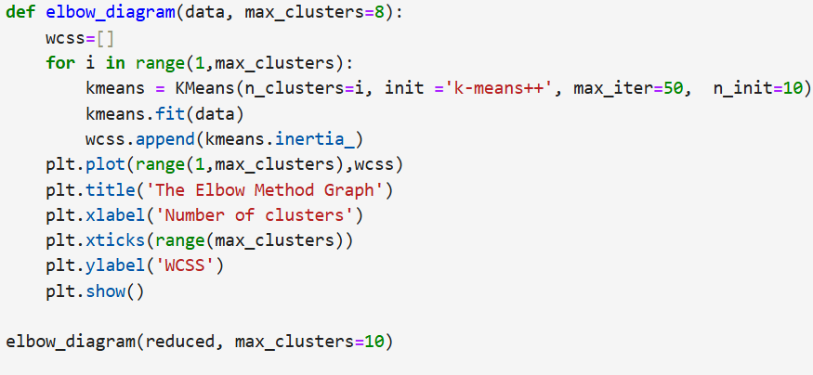
The elbow method is a heuristic used in cluster analysis to determine the optimal number of clusters for algorithms like K-means. The goal is to identify a "k" that balances the trade-off between the number of clusters and the variance within clusters.

How the Elbow Method Works
- Compute the Clustering Metric:
  - For each number of clusters kkk, compute the clustering metric. Typically, this metric is the Within-Cluster Sum of Squares (WCSS), which measures the total distance between each point and the centroid of its cluster.
- Plot the Metric Against Number of Clusters:
  - Plot the WCSS values on the y-axis and the number of clusters kkk on the x-axis.
- Identify the "Elbow" Point:
  - Look for the point on the plot where the WCSS starts to decrease at a slower rate. This point is called the "elbow." It represents a good balance between the number of clusters and the clustering quality.

3.03 DBSCAN
- DBSCAN (Density-Based Spatial Clustering of Applications with Noise) is a popular clustering algorithm used in data science and machine learning for finding clusters of arbitrary shapes and identifying outliers or noise in the data.
- Goals
  - Create transformation functions to produce numeric output from textual input
  - Apply the DBSCAN clustering algorithm to our data
  - Visualize the resulting clusters
  - Attempt to identify anomalies in the clusters
- DBSCAN class from the Scikit Learn Clustering package
- PCA package for dimensionality reduction
- Use StandardScaler to scale the data.
  - scaler = StandardScaler()
  - scaler.fit(data)
  - scaled = scaler.transform(data)

3.04 Support Vector Classifiers
- Support Vector Classifier (SVC) is a type of Support Vector Machine (SVM) used for classification tasks in machine learning. It aims to find the optimal hyperplane that separates different classes in the feature space with the maximum margin.
  - Hyperplane:In a 2-dimensional space, a hyperplane is a line that separates the data points into two classes. In higher dimensions, it's a plane or a higher-dimensional analog.
  - Margin: distance between the hyperplane and the closest data points from each class. SVC aims to maximize this margin.
  - Support Vectors: data points that lie closest to the hyperplane. These points are critical for defining the position and orientation of the hyperplane.
- It is traditional in statistical and machine learning to use X to represent the training data and Y to represent the training labels or expected outputs.
- from sklearn.svm import SVC
- training:
  - svc = SVC(kernel='linear', verbose=True)
  - svc.fit(x[60000:70000], y[60000:70000])
- predict
  - predictions = svc.predict(x_test)
  - accuracy = 0
  - for i in range(0,len(y_test)):
  - if(y_test[i] == predictions[i]):
  - accuracy = accuracy + 1

3.05 Support Vector Machines (7/22)
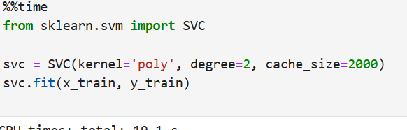
- The polynomial kernel is a powerful tool used in Support Vector Machines (SVM) to handle non-linearly separable data. Here's a detailed explanation of how it works and why it's useful:

What is a Kernel Function?
- In machine learning, a kernel function is a mathematical function that computes the dot product of two vectors in a higher-dimensional space without explicitly transforming the data into that space. This is known as the "kernel trick." The kernel trick allows algorithms like Support Vector Machines (SVM) to operate in high-dimensional spaces efficiently.

Polynomial Kernel Overview
- Polynomial Kernel Function:
- The polynomial kernel function maps input data into a higher-dimensional space using polynomial functions. It allows the SVM to fit more complex decision boundaries than a linear kernel by considering interactions between features.
- Radial Basis Function (RBF) Kernel is a popular kernel used in Support Vector Machines (SVM) and other machine learning algorithms to handle non-linearly separable data. The RBF kernel, also known as the Gaussian kernel, is particularly useful for creating complex decision boundaries by implicitly mapping input data into a higher-dimensional space
- Overview of the RBF Kernel: The RBF kernel function computes the similarity between two data points in the feature space, transforming the data into a higher-dimensional space where a linear separation may be easier to achieve. It is widely used due to its ability to handle non-linear relationships effectively.

Summary of Kernel Options
- Linear Kernel ('linear'): Simple linear decision boundary. Suitable for linearly separable data.
- Polynomial Kernel ('poly'): Non-linear decision boundaries with polynomial terms. Use degree to set the polynomial degree and coef0 for the constant term.
- Radial Basis Function Kernel ('rbf'): Non-linear decision boundaries using Gaussian functions. Use gamma to control the spread of the kernel.
- Sigmoid Kernel ('sigmoid'): Non-linear decision boundaries using the hyperbolic tangent function. Use gamma and coef0 to control the kernel behavior.

3.06 Decision Trees
- Decision trees are a popular method in machine learning and data mining for both classification and regression tasks. They are easy to understand and interpret, making them a great tool for explaining decisions and predictions.
- A decision tree is made up of nodes that represent decisions or tests on attributes, branches that represent the outcome of those tests, and leaves that represent the final decision or prediction.
- Root Node: The top node that represents the entire dataset or the initial decision.
- Internal Nodes: These represent features or attributes on which decisions are made.
- Branches: These are the paths that connect nodes, representing the outcome of a decision or test.
- Leaf Nodes: These represent the final output or class labels in a classification problem, or the predicted value in a regression problem.]
How They Work
- Classification Trees: These trees are used to classify data into predefined classes. At each node, the tree splits the data based on the feature that best separates the classes. This splitting continues until the data in each leaf node belongs to a single class or a stopping criterion is met.
- Regression Trees: These trees predict a continuous value. Instead of classifying data, the tree splits the data into regions where the average target value is computed for each region.

1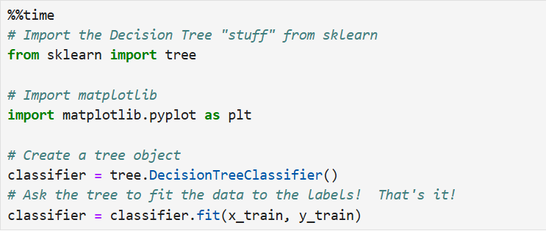
3.07 Random Forests (7/24)
from sklearn.ensemble import RandomForestClassifier
Random Forest is an ensemble learning method that builds upon the concept of decision trees to create a more robust and accurate model. It improves performance and mitigates some of the limitations of single decision trees by aggregating the predictions of multiple trees. Here’s a detailed overview:

What is Random Forest?
A Random Forest is an ensemble of decision trees, typically trained with the bagging method (Bootstrap Aggregating). It combines the predictions from several decision trees to produce a final prediction.

Key Concepts
- Bagging:
  - Bootstrap Sampling: Multiple decision trees are trained on different subsets of the training data. These subsets are created by randomly sampling the training data with replacement (bootstrapping). Each tree sees a slightly different view of the data.
  - Aggregation: For classification, the final prediction is made by majority voting (the class that gets the most votes). For regression, it is done by averaging the predictions of all trees.
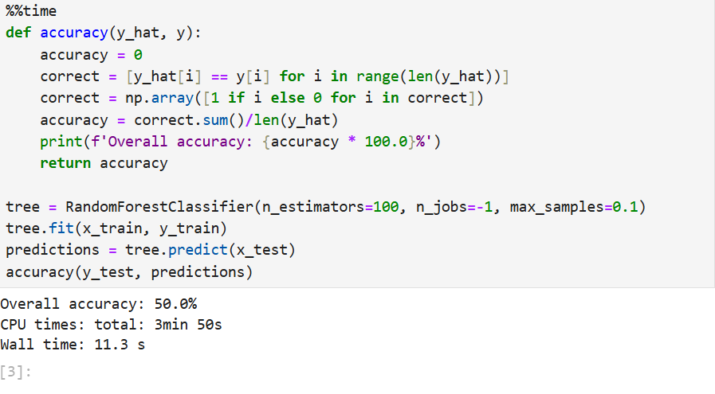
GradientBoostingClassifier from sklearn.ensemble.
4.01 Linear Regression
- Bollinger Bands are a popular technical analysis tool used in financial markets to measure the volatility and price levels of a security. Developed by John Bollinger in the 1980s, this tool helps traders and investors identify potential buy and sell signals based on price movements and volatility. Here’s a detailed overview
  - Components of Bollinger Bands Middle Band:Calculation: This is typically a simple moving average (SMA) of the security's price, commonly set to a 20-day period. It serves as the base for the upper and lower bands.
- polyfit()
- 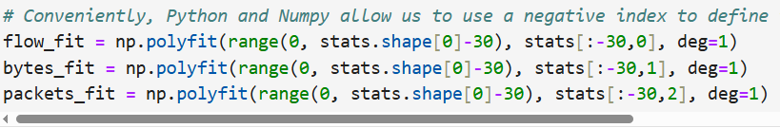
- In machine learning and statistical modeling, loss values are metrics used to quantify how well a model's predictions match the actual outcomes. They are crucial for training algorithms and evaluating model performance.A loss value represents the discrepancy between the predicted values and the actual values (ground truth) in a dataset. The goal of most machine learning algorithms is to minimize this loss value, leading to better model performance.
  - mean squared error
4.02 First Neural Network
- sentiment classification.
- Understand and use Multi-Hot Encoding
- Create a TensorFlow model using dense layers
- Understand what the Bag of Words approach is and how it is applied
- See the difference between "Machine Learning" and "Understanding"
- from tensorflow.keras import models, layers, datasets
- layer that accepts our input must be informed about the number of dimensions (features) found in the data that will be passed to it. We must also select an activation function for each of the layers.
- What are hyperparameters? They are effectively everything that isn't within the neurons themselves. For example, the number of layers, the number of neurons in the layers, the activation functions that we use, the optimizer that we use, etc.

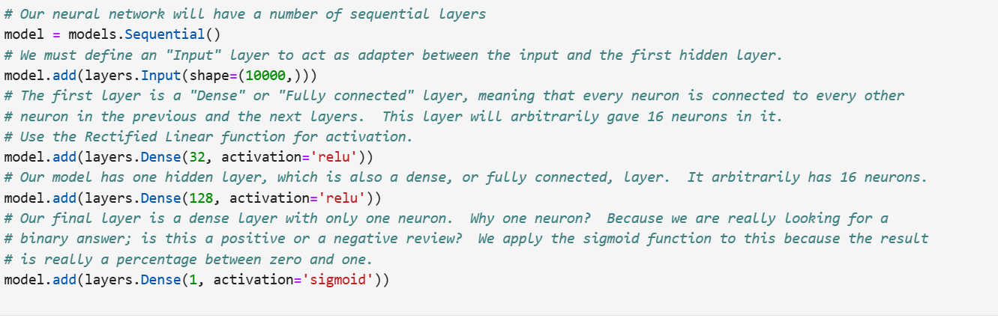

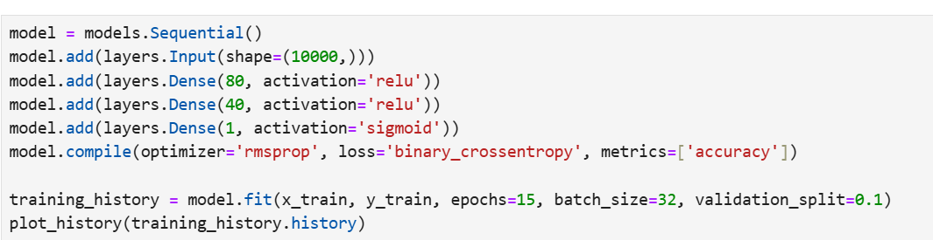

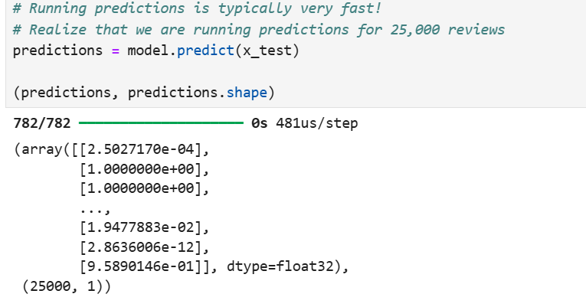
4.03 BOW Ham vs. Spam (7/27)
4.04 FInding Non-IP Packets (7/28)
4.05 Realtime Anomalous Protocols (7/29)

Friday
5.01 Malware erection by CNN (7/30)
5.02 Ham vs. Spam CNN Style (7/31)
5.03 Applying CNNs to Text Classifications (8/1)
5.04 Anomaly detection in Logs (8/2)
5.05 Protocol Anomalies Revisted (8/3)

6.01 Solving Simple CAPTCHAs (8/4)
6.02 Solving CAPTCHAs Fuctional Models (8/5)
6.03 Hammers and Nails (8/6)

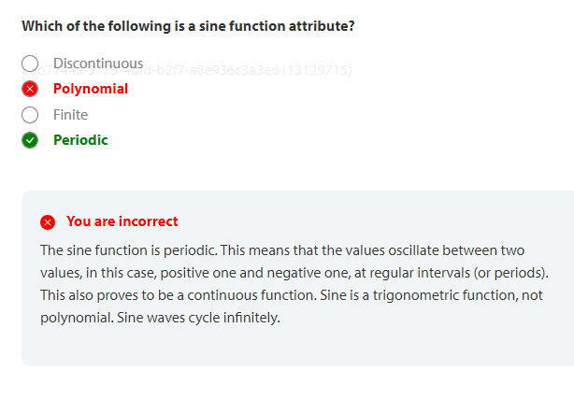

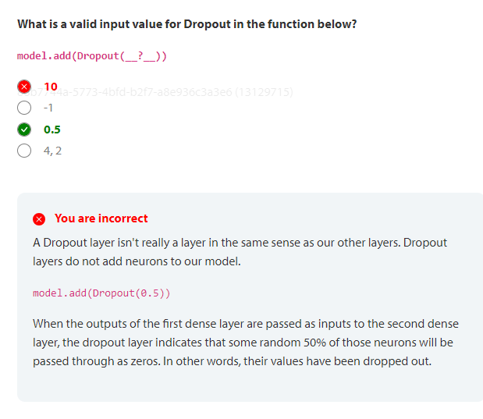

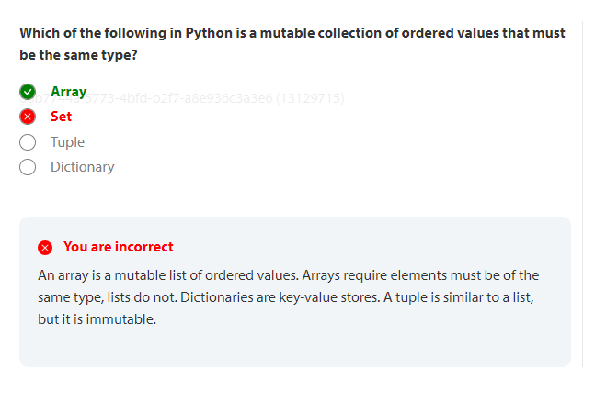
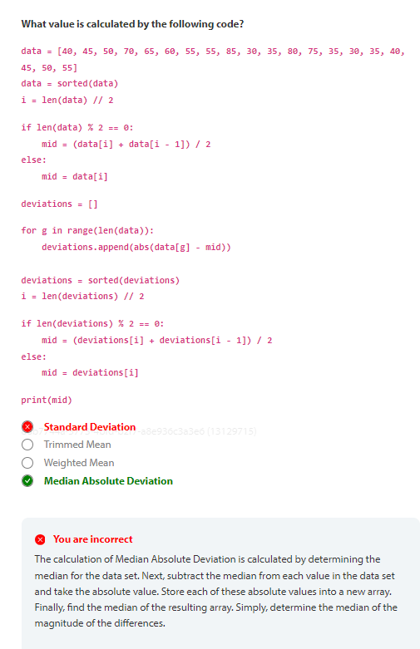

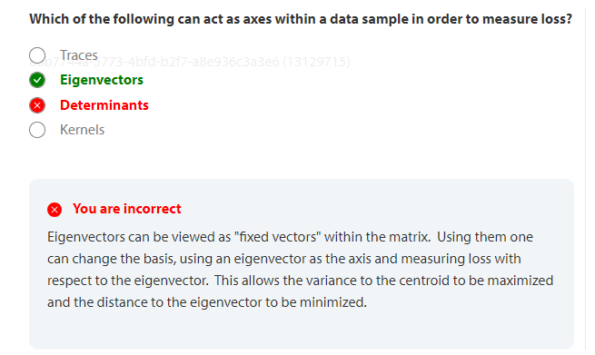

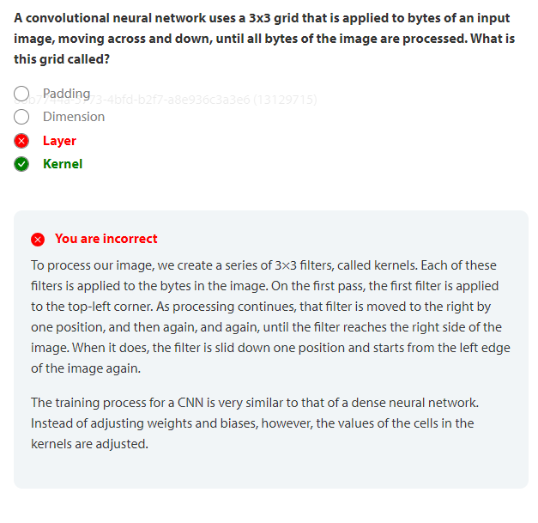
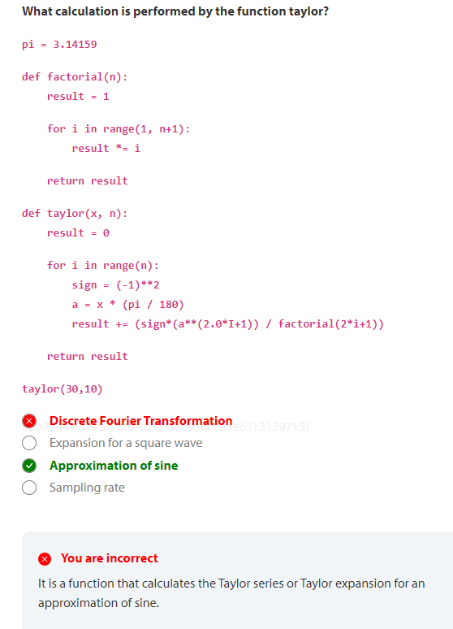

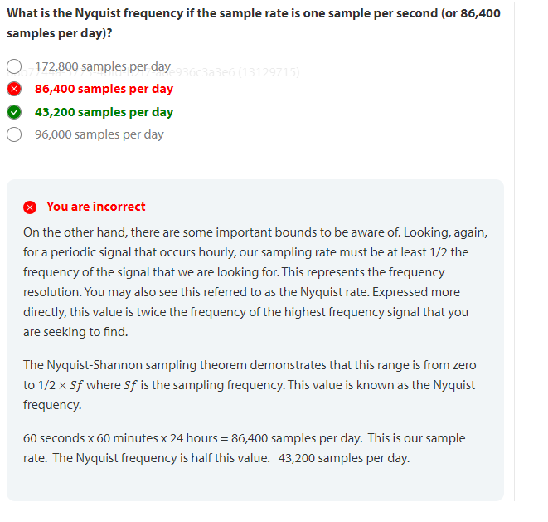

stringfield
gini coefficient .5

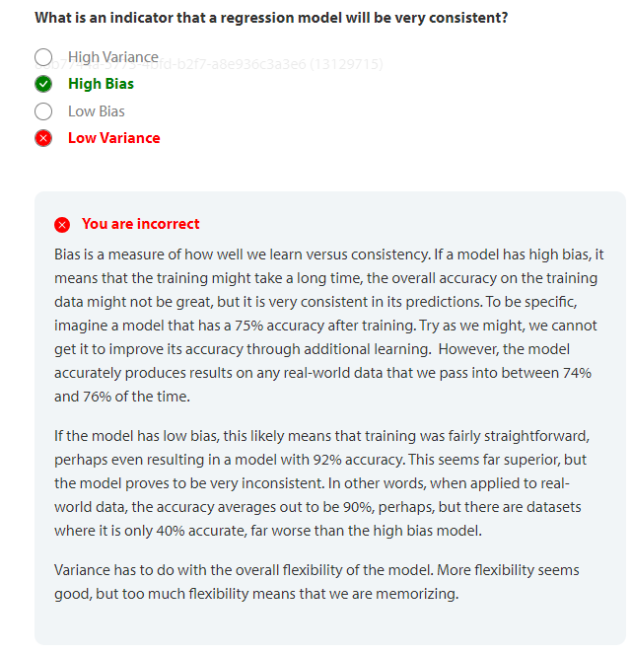

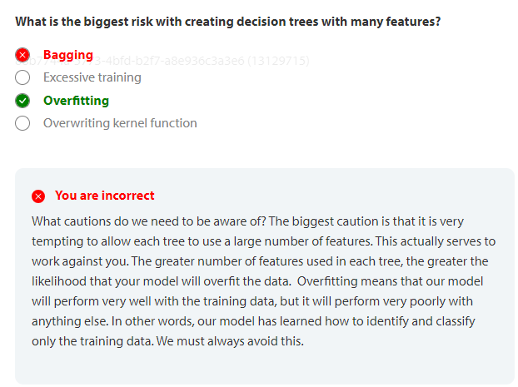

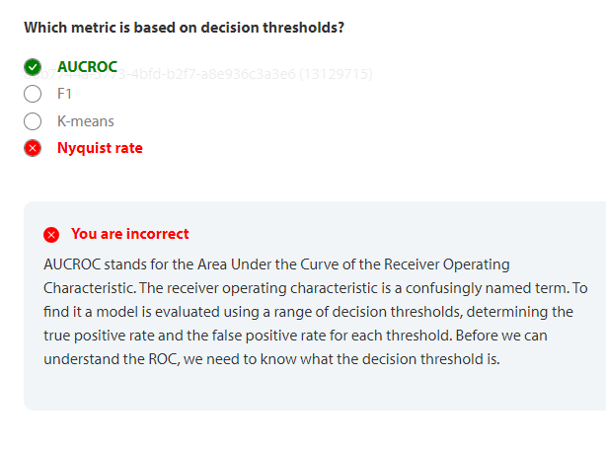

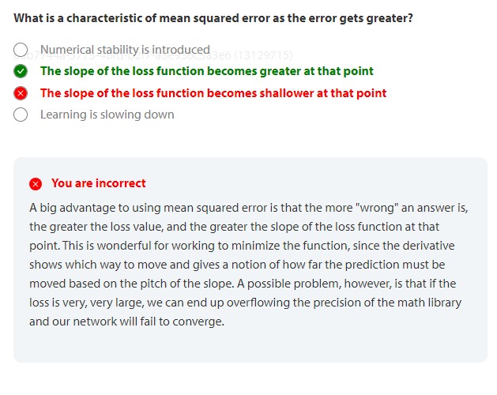

Relu

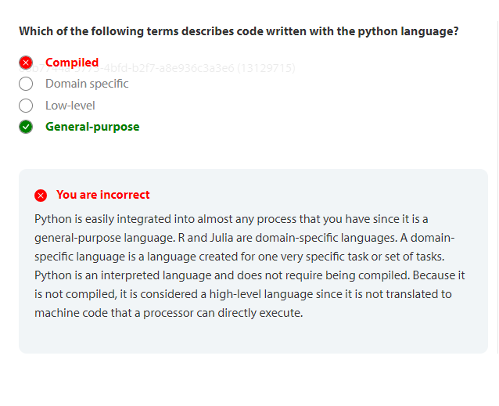

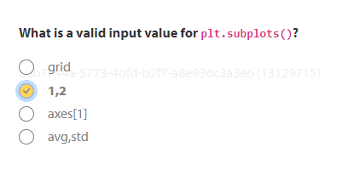
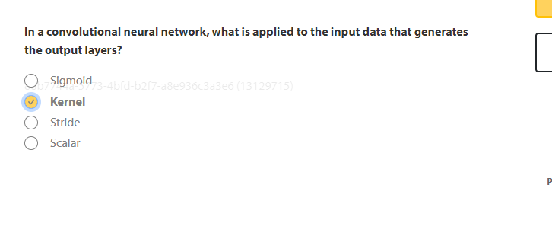
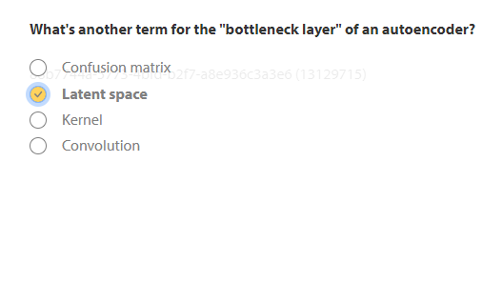
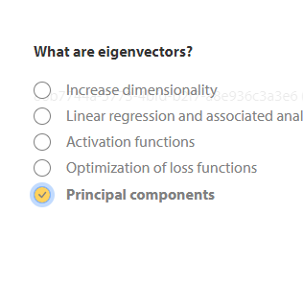

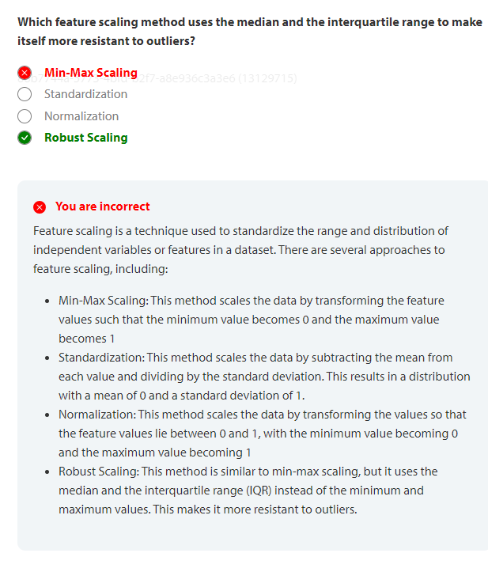
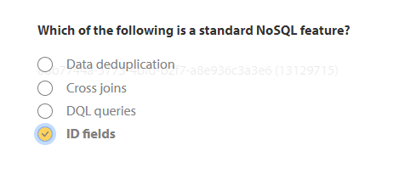
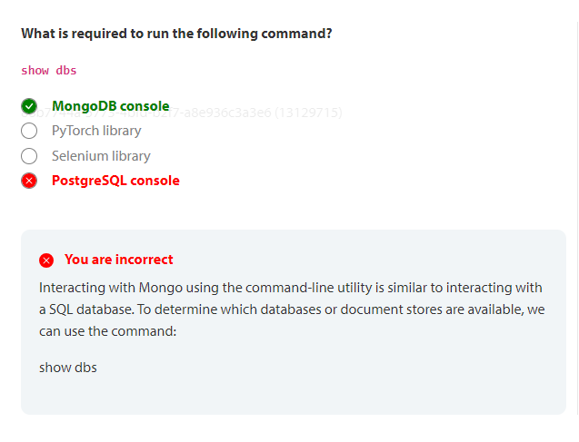
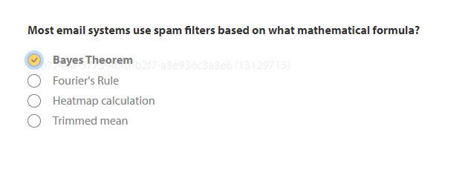

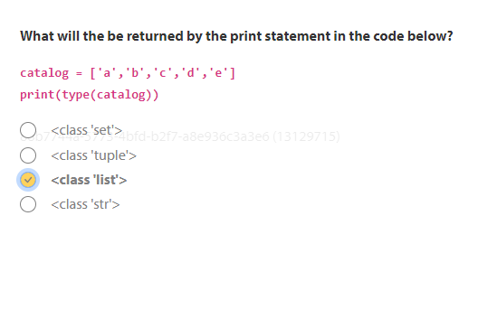

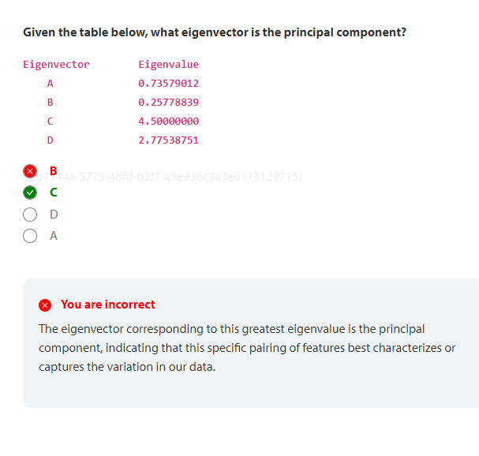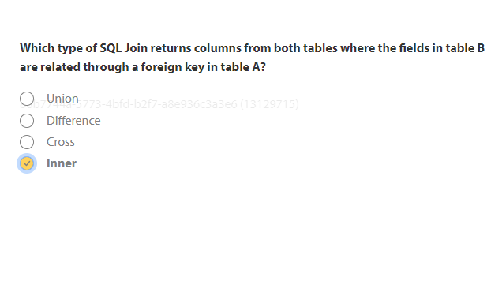
I have

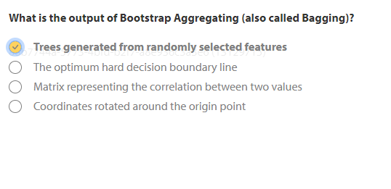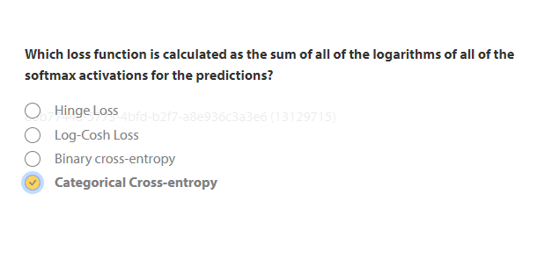
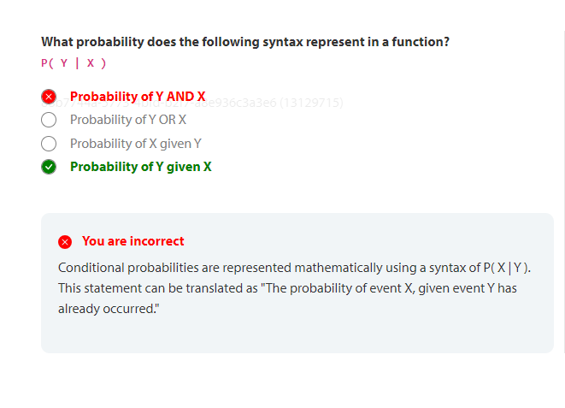
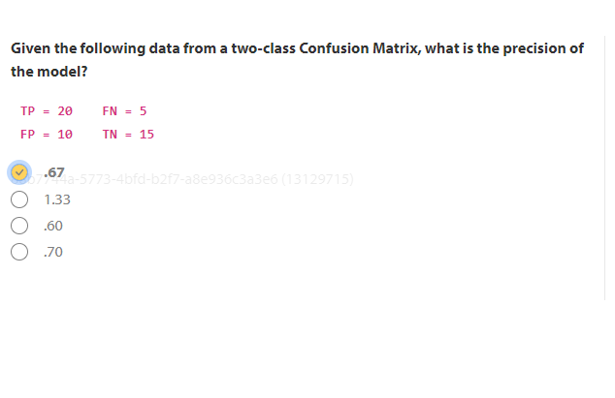
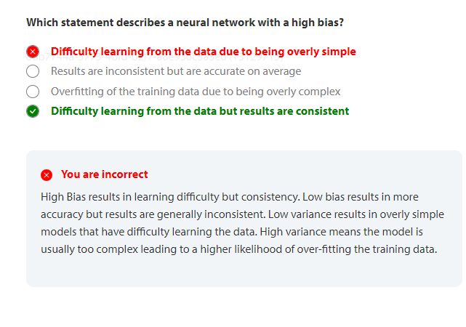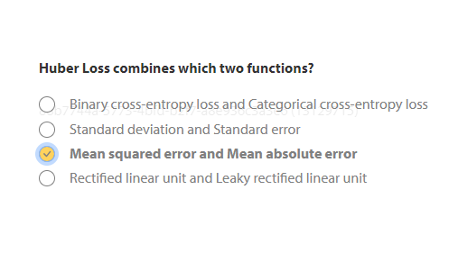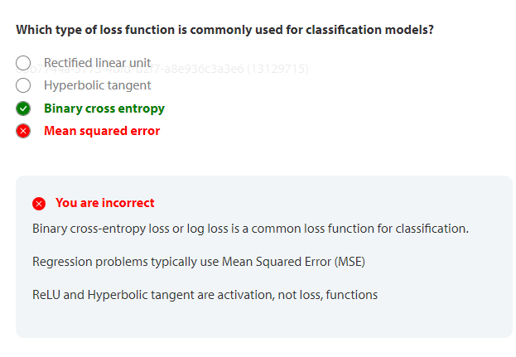
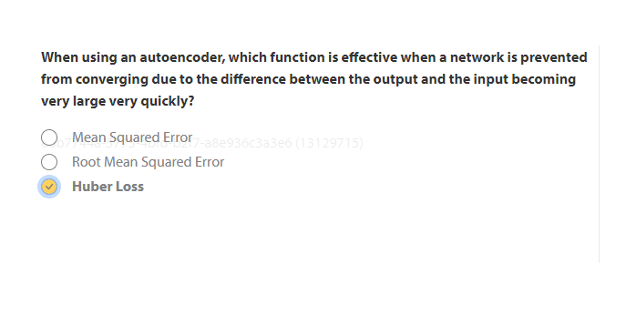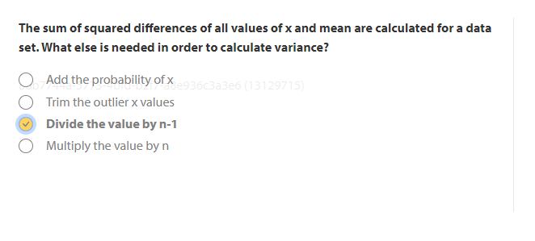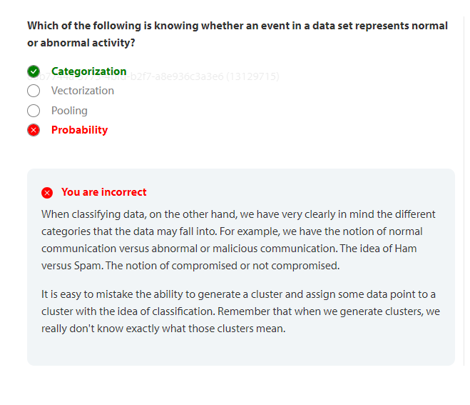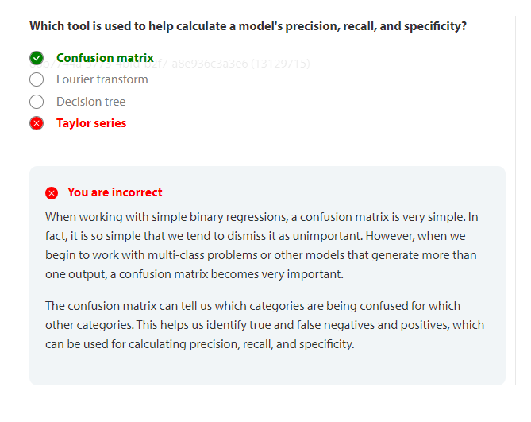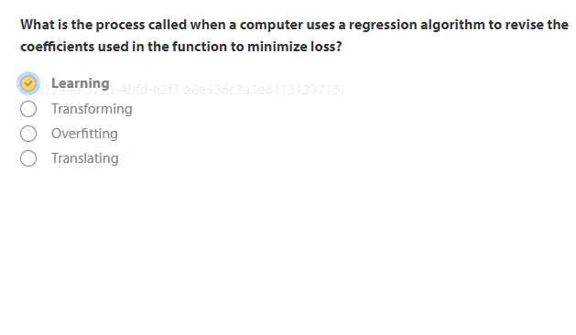
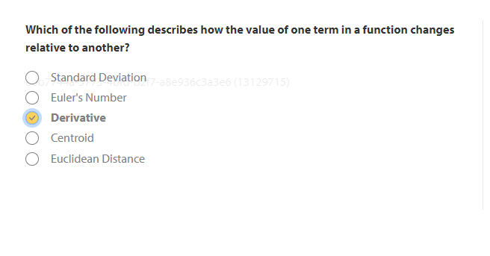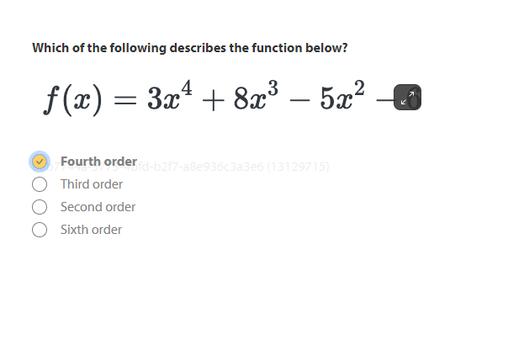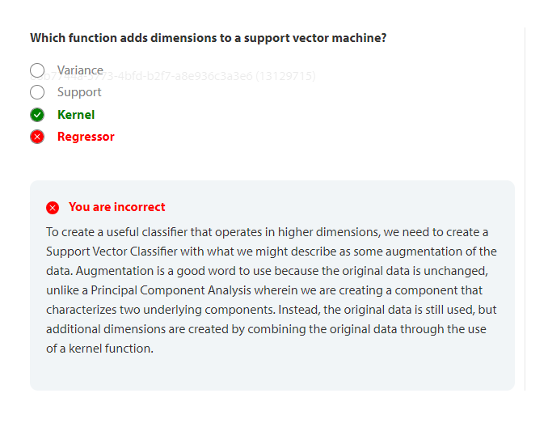

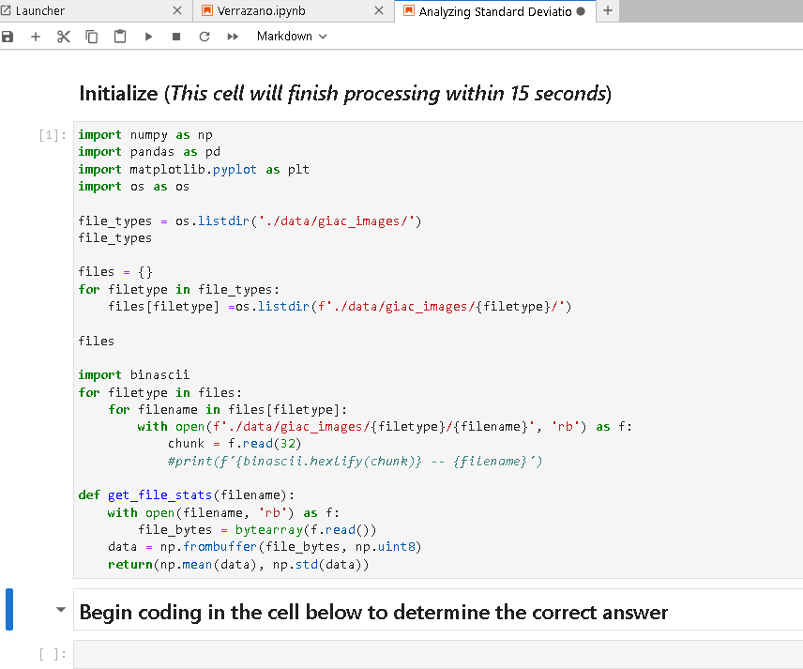

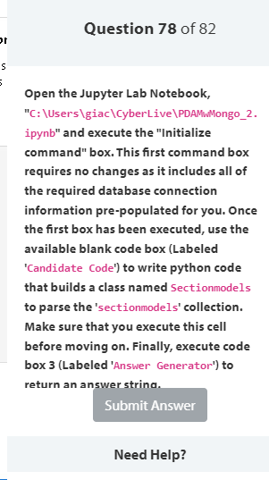
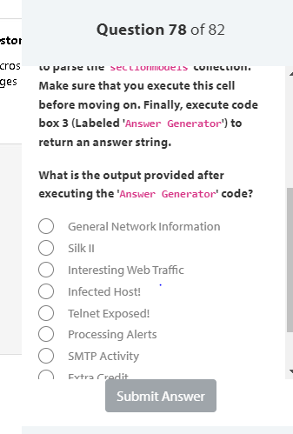

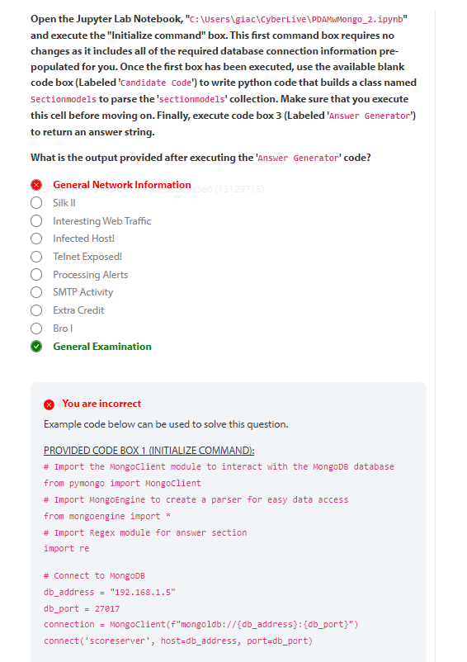You are incorrect
Example code below can be used to solve this question.
PROVIDED CODE BOX 1 (INITIALIZE COMMAND):
# Import the MongoClient module to interact with the MongoDB database
from pymongo import MongoClient
# Import MongoEngine to create a parser for easy data access
from mongoengine import *
# Import Regex module for answer section
import re
# Connect to MongoDB
db_address = "192.168.1.5"
db_port = 27017
connection = MongoClient(f"mongoldb://{db_address}:{db_port}")
connect('scoreserver', host=db_address, port=db_port)
# Connect to the Scoreserver database
db = connection.scoreserver
BLANK BOX SOLUTION (CANDIDATE CODE):
# Show an example entry for 'sectionmodels' to identify field names
db['sectionmodels'].find_one()
# Define a class named Sectionmodels
class Sectionmodels(Document):
index = IntField()
value = IntField()
description = StringField()
name = StringField()
questions = ListField(StringField())
question = StringField()
v = IntField(db_field='__v')
PROVIDED CODE BOX 3 (ANSWER GENERATOR):
# Once your class has been created, execute the box. Your answer will be shown.
GIAC_Candidate_Class = Sectionmodels
for number in range(65):
try:
answer = re.findall('Zeek', Sectionmodels.objects()[number].description)
If len(answer) > 1:
print(f'The answer is:\n')
print(Sectionmodels.objects()[number].name)
else:
continue
except:
print(f'Please double check that your class name is "Sectionmodels" and try again.')
break
The output of the code above, if the class is written correctly will display the name of the section that includes the word "Zeek" more than once in the description field. It is presented to the candidate simply as "the answer" in the output and will be "General Examination". The only code required to be written by the candidate is the Class definition statement.

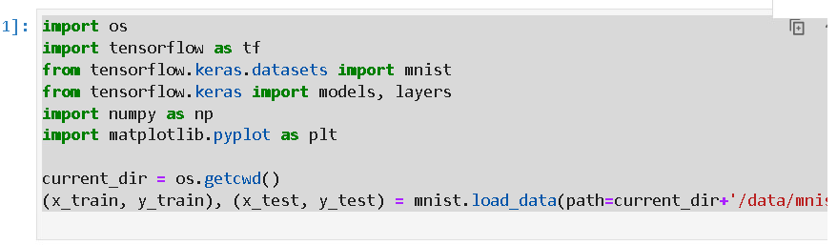

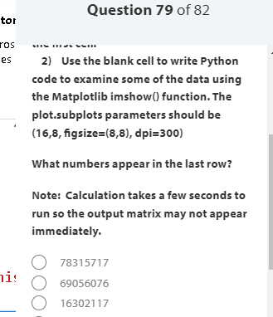

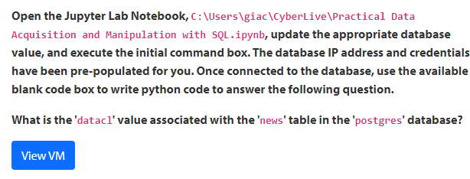

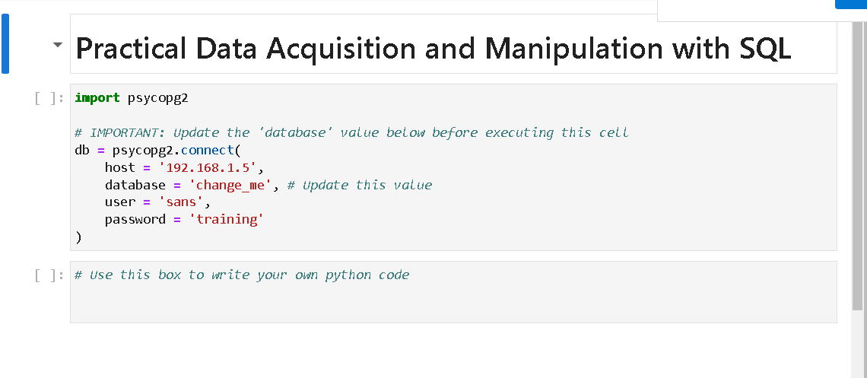

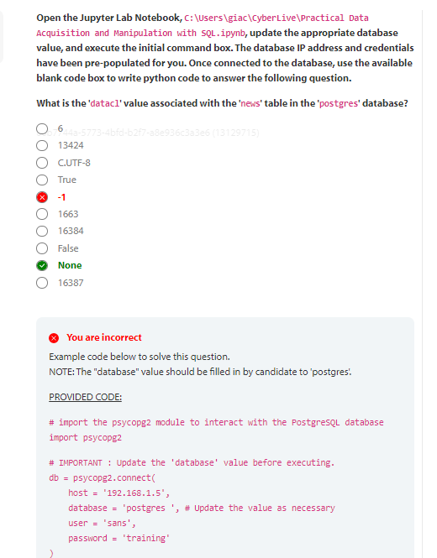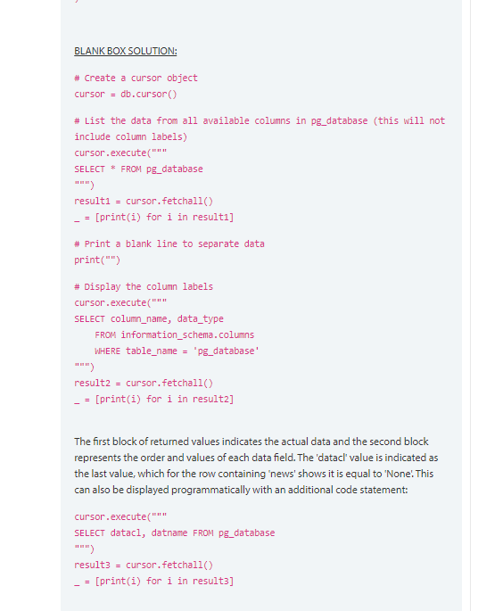

88b7744a-5773-4bfd-b2f7-a8e936c3a3e6 (13129715)
6
13424
C.UTF-8
True
-1
1663
16384
False
None
16387
You are incorrect
Example code below to solve this question.
NOTE: The "database" value should be filled in by candidate to 'postgres'.
PROVIDED CODE:
# import the psycopg2 module to interact with the PostgreSQL database
import psycopg2
# IMPORTANT : Update the 'database' value before executing.
db = psycopg2.connect(
host = '192.168.1.5',
database = 'postgres ', # Update the value as necessary
user = 'sans',
password = 'training'
)

BLANK BOX SOLUTION:
# Create a cursor object
cursor = db.cursor()
# List the data from all available columns in pg_database (this will not include column labels)
cursor.execute("""
SELECT * FROM pg_database
""")
result1 = cursor.fetchall()
_ = [print(i) for i in result1]
# Print a blank line to separate data
print("")
# Display the column labels
cursor.execute("""
SELECT column_name, data_type
FROM information_schema.columns
WHERE table_name = 'pg_database'
""")
result2 = cursor.fetchall()
_ = [print(i) for i in result2]
The first block of returned values indicates the actual data and the second block represents the order and values of each data field. The 'datacl' value is indicated as the last value, which for the row containing 'news' shows it is equal to 'None'. This can also be displayed programmatically with an additional code statement:
cursor.execute("""
SELECT datacl, datname FROM pg_database
""")
result3 = cursor.fetchall()
_ = [print(i) for i in result3]

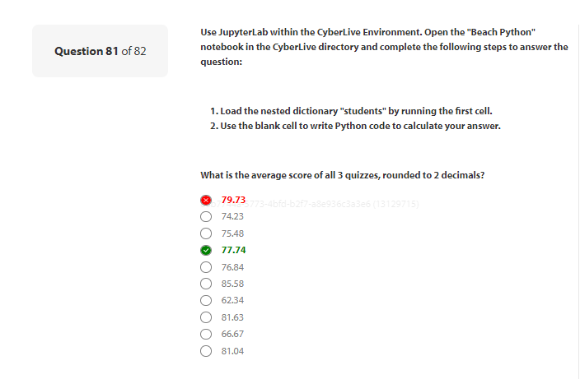

You are incorrect
Here are a couple of solutions:
Solution 1:
quiz_roll = []
flatlist = []
total = 0
i=0
avg = 0.0
for key, subdict in students.items():
for k, v in subdict.items():
if k == 'Quiz1' or k == 'Quiz2' or k == 'Quiz3':
temp = students[key][k]
quiz_roll.append(temp)
i += 1
flatlist=[element for sublist in quiz_roll for element in sublist]
total = sum(flatlist)
avg = round(total / i, 2)
print(total,i,avg)
Solution 2
tab = 0
i=0
avg = 0.0
for key, subdict in students.items():
for k, v in subdict.items():
if k == 'Quiz1' or k == 'Quiz2' or k == 'Quiz3':
temp = students[key][k]
tab += int(temp[0])
i += 1
avg = round(tab/ i, 2)
print(tab,i,avg)

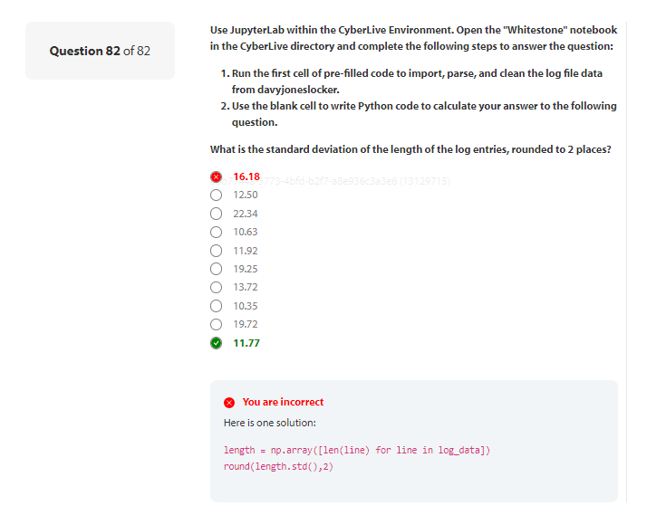

try 2

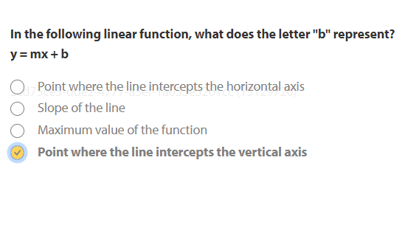

my_set = {1, 2, 3}
my_dict = { "name": "Alice", "age": 30, "city": "New York" }
my_list = [1, 2, 3, 4, 5]
my_tuple = (1, 2, 3)


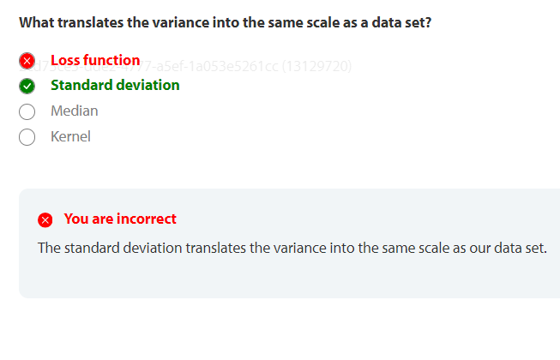

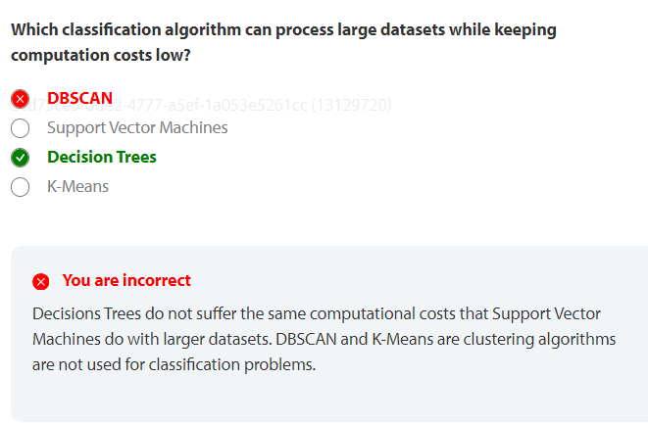
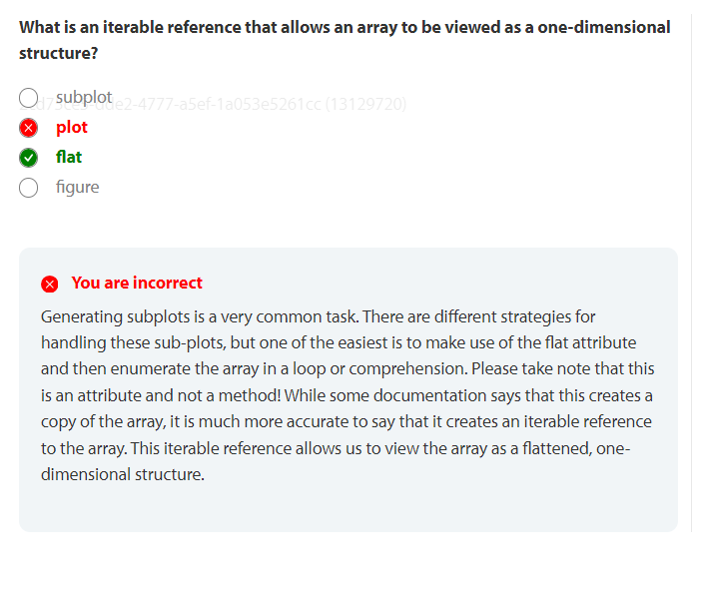

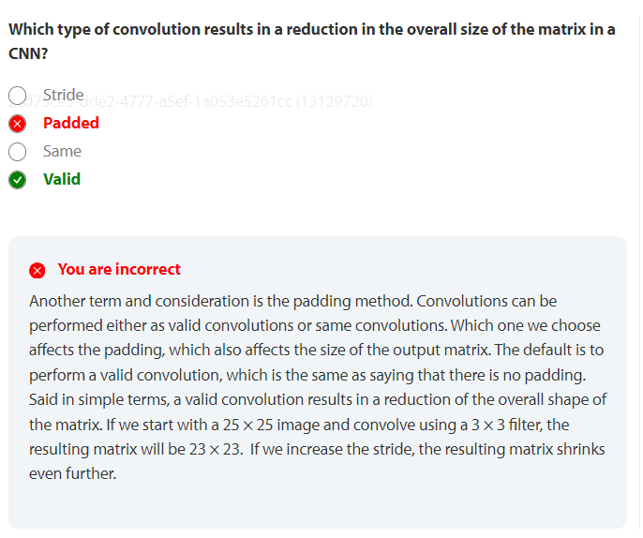

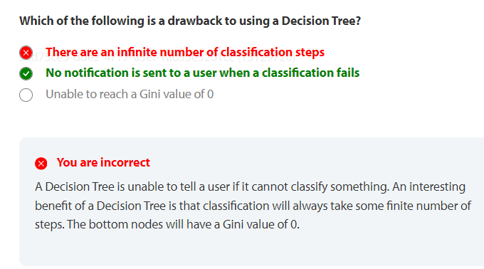
You are incorrect
A Decision Tree is unable to tell a user if it cannot classify something. An interesting benefit of a Decision Tree is that classification will always take some finite number of steps. The bottom nodes will have a Gini value of 0.
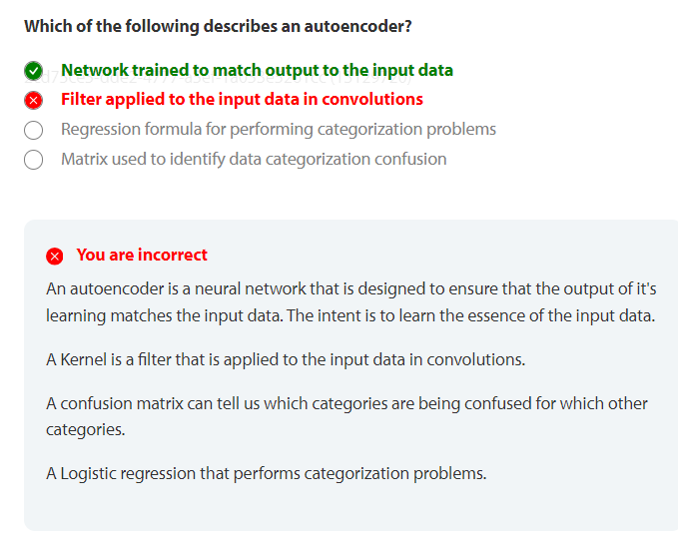

Question 42 of 82
Which of the following describes an autoencoder?
2cd75ce5-dde2-4777-a5ef-1a053e5261cc (13129720)
Network trained to match output to the input data
Filter applied to the input data in convolutions
Regression formula for performing categorization problems
Matrix used to identify data categorization confusion
You are incorrect
An autoencoder is a neural network that is designed to ensure that the output of it's learning matches the input data. The intent is to learn the essence of the input data.
A Kernel is a filter that is applied to the input data in convolutions.
A confusion matrix can tell us which categories are being confused for which other categories.
A Logistic regression that performs categorization problems

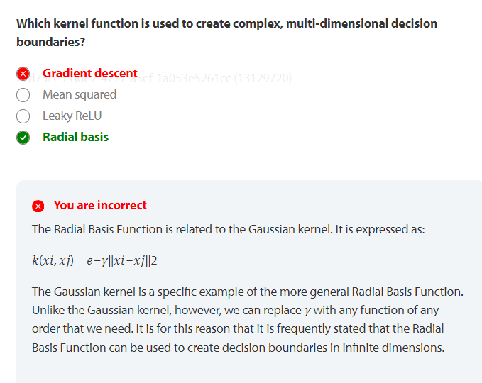

2cd75ce5-dde2-4777-a5ef-1a053e5261cc (13129720)
Gradient descent
Mean squared
Leaky ReLU
Radial basis
You are incorrect
The Radial Basis Function is related to the Gaussian kernel. It is expressed as:
𝑘(𝑥𝑖, 𝑥𝑗) = 𝑒−𝛾‖𝑥𝑖−𝑥𝑗‖2
The Gaussian kernel is a specific example of the more general Radial Basis Function. Unlike the Gaussian kernel, however, we can replace 𝛾 with any function of any order that we need. It is for this reason that it is frequently stated that the Radial Basis Function can be used to create decision boundaries in infinite dimensions.

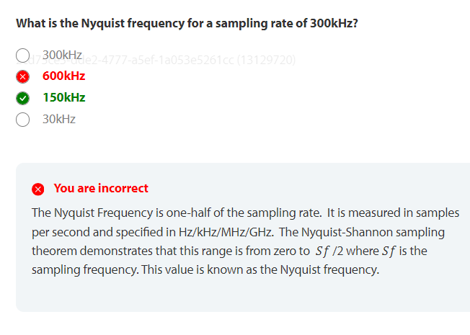
300kHz
600kHz
150kHz
30kHz
You are incorrect
The Nyquist Frequency is one-half of the sampling rate. It is measured in samples per second and specified in Hz/kHz/MHz/GHz. The Nyquist-Shannon sampling theorem demonstrates that this range is from zero to 𝑆𝑓 /2 where 𝑆𝑓 is the sampling frequency. This value is known as the Nyquist frequency.

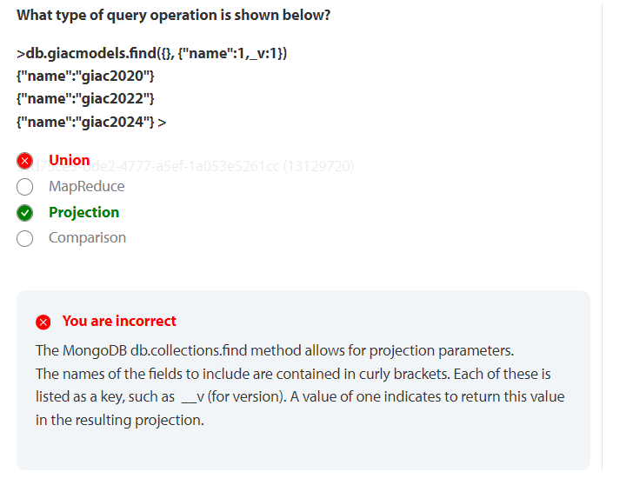
2cd75ce5-dde2-4777-a5ef-1a053e5261cc (13129720)
Union
MapReduce
Projection
Comparison
You are incorrect
The MongoDB db.collections.find method allows for projection parameters. The names of the fields to include are contained in curly brackets. Each of these is listed as a key, such as __v (for version). A value of one indicates to return this value in the resulting projection.

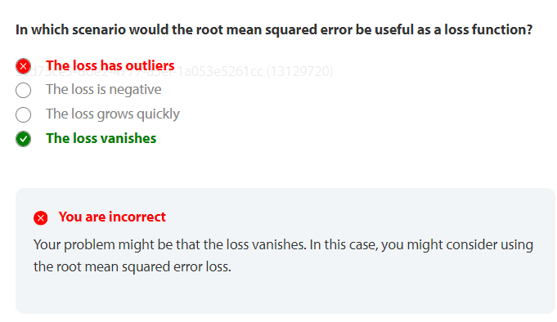

The loss has outliers
The loss is negative
The loss grows quickly
The loss vanishes
You are incorrect
Your problem might be that the loss vanishes. In this case, you might consider using the root mean squared error loss.

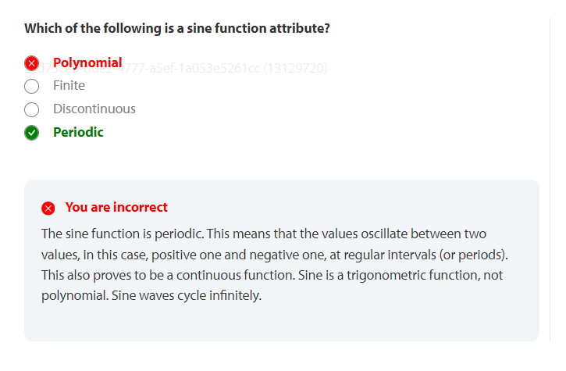
You are incorrect
The sine function is periodic. This means that the values oscillate between two values, in this case, positive one and negative one, at regular intervals (or periods). This also proves to be a continuous function. Sine is a trigonometric function, not polynomial. Sine waves cycle infinitely.

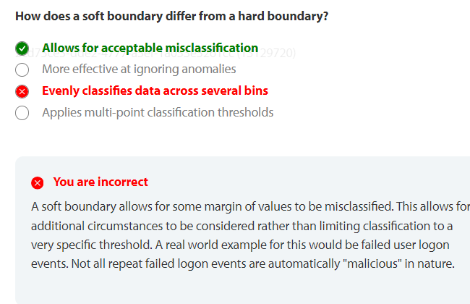

Allows for acceptable misclassification
More effective at ignoring anomalies
Evenly classifies data across several bins
Applies multi-point classification thresholds
You are incorrect
A soft boundary allows for some margin of values to be misclassified. This allows for additional circumstances to be considered rather than limiting classification to a very specific threshold. A real world example for this would be failed user logon events. Not all repeat failed logon events are automatically "malicious" in nature.

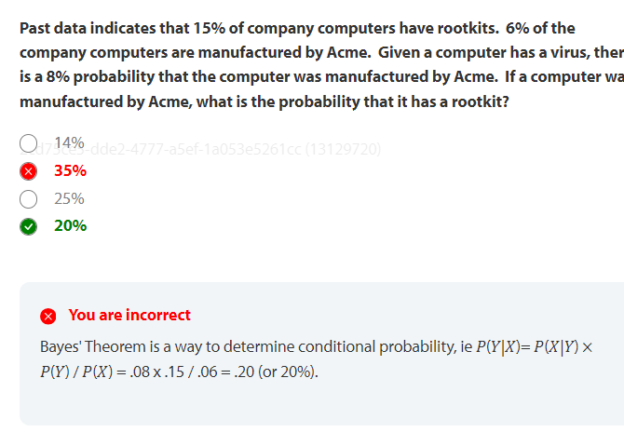
14%
35%
25%
20%
You are incorrect
Bayes' Theorem is a way to determine conditional probability, ie 𝑃(𝑌|𝑋)= 𝑃(𝑋|𝑌) × 𝑃(𝑌) / 𝑃(𝑋) = .08 x .15 / .06 = .20 (or 20%).

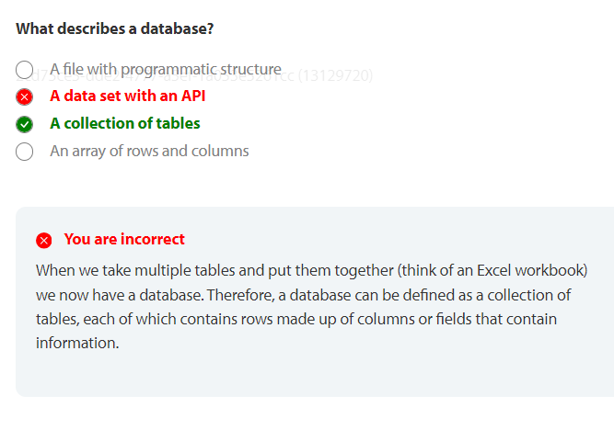

A file with programmatic structure
A data set with an API
A collection of tables
An array of rows and columns
You are incorrect
When we take multiple tables and put them together (think of an Excel workbook) we now have a database. Therefore, a database can be defined as a collection of tables, each of which contains rows made up of columns or fields that contain information.

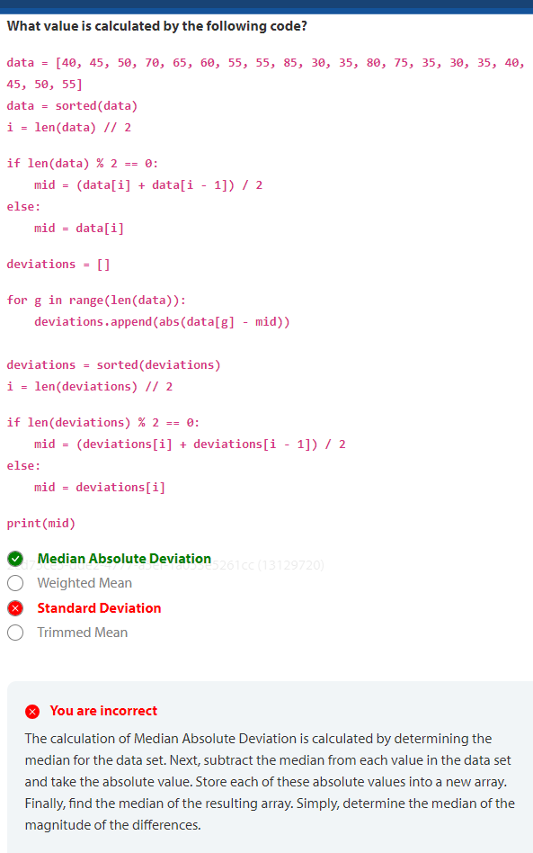

2cd75ce5-dde2-4777-a5ef-1a053e5261cc (13129720)
Median Absolute Deviation
Weighted Mean
Standard Deviation
Trimmed Mean
You are incorrect
The calculation of Median Absolute Deviation is calculated by determining the median for the data set. Next, subtract the median from each value in the data set and take the absolute value. Store each of these absolute values into a new array. Finally, find the median of the resulting array. Simply, determine the median of the magnitude of the differences.

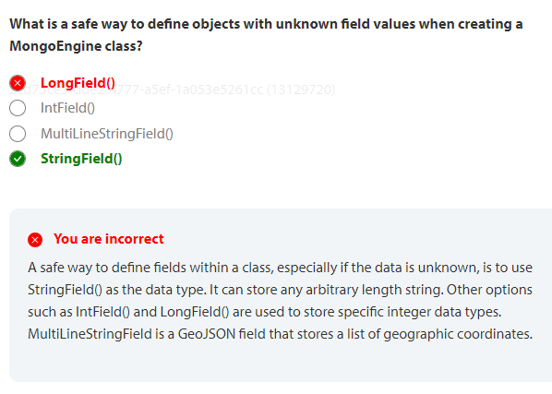

LongField()
IntField()
MultiLineStringField()
StringField()
You are incorrect
A safe way to define fields within a class, especially if the data is unknown, is to use StringField() as the data type. It can store any arbitrary length string. Other options such as IntField() and LongField() are used to store specific integer data types. MultiLineStringField is a GeoJSON field that stores a list of geographic coordinates.

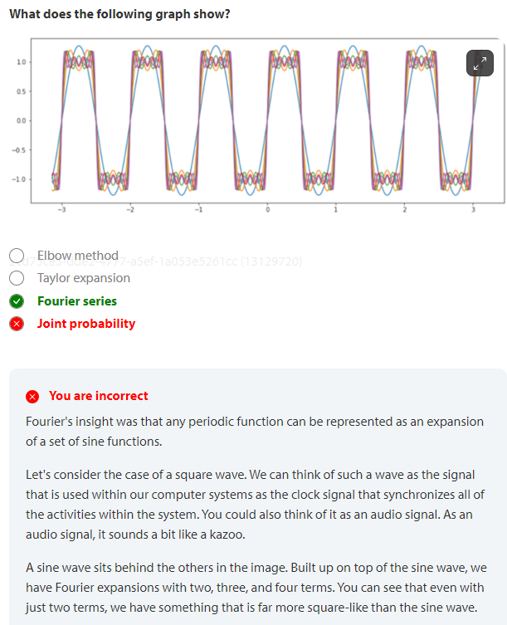

Elbow method
Taylor expansion
Fourier series
Joint probability
You are incorrect
Fourier's insight was that any periodic function can be represented as an expansion of a set of sine functions.
Let's consider the case of a square wave. We can think of such a wave as the signal that is used within our computer systems as the clock signal that synchronizes all of the activities within the system. You could also think of it as an audio signal. As an audio signal, it sounds a bit like a kazoo.
A sine wave sits behind the others in the image. Built up on top of the sine wave, we have Fourier expansions with two, three, and four terms. You can see that even with just two terms, we have something that is far more square-like than the sine wave.

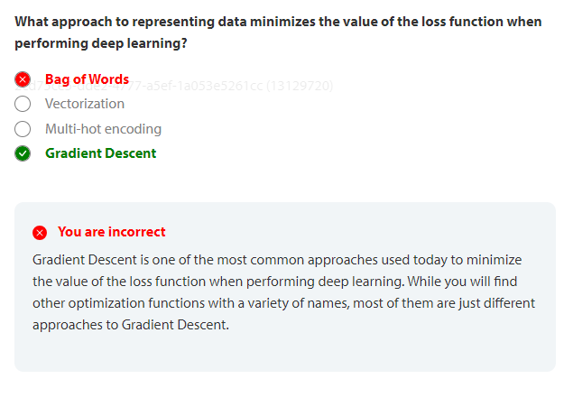

Bag of Words
Vectorization
Multi-hot encoding
Gradient Descent
You are incorrect
Gradient Descent is one of the most common approaches used today to minimize the value of the loss function when performing deep learning. While you will find other optimization functions with a variety of names, most of them are just different approaches to Gradient Descent.

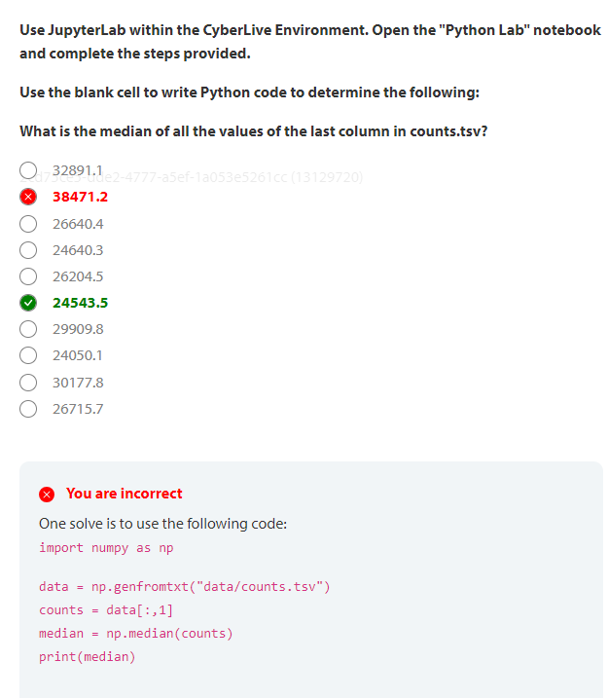

2cd75ce5-dde2-4777-a5ef-1a053e5261cc (13129720)
32891.1
38471.2
26640.4
24640.3
26204.5
24543.5
29909.8
24050.1
30177.8
26715.7
You are incorrect
One solve is to use the following code:
import numpy as np
data = np.genfromtxt("data/counts.tsv")
counts = data[:,1]
median = np.median(counts)
print(median)

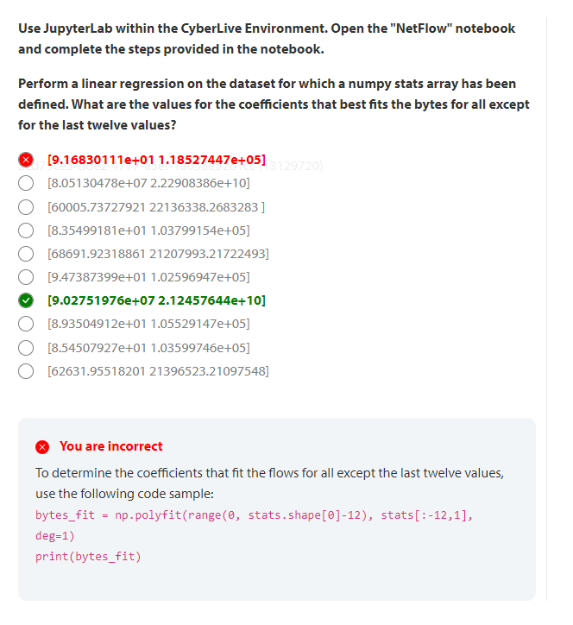

2cd75ce5-dde2-4777-a5ef-1a053e5261cc (13129720)
[9.16830111e+01 1.18527447e+05]
[8.05130478e+07 2.22908386e+10]
[60005.73727921 22136338.2683283 ]
[8.35499181e+01 1.03799154e+05]
[68691.92318861 21207993.21722493]
[9.47387399e+01 1.02596947e+05]
[9.02751976e+07 2.12457644e+10]
[8.93504912e+01 1.05529147e+05]
[8.54507927e+01 1.03599746e+05]
[62631.95518201 21396523.21097548]
You are incorrect
To determine the coefficients that fit the flows for all except the last twelve values, use the following code sample:
bytes_fit = np.polyfit(range(0, stats.shape[0]-12), stats[:-12,1], deg=1)
print(bytes_fit)

Practice Passed
Score: 74% (Passed)

